**TO FIND THE RESISTANCE OF RESISTOR BY COLOR CODING METHOD**

**LAB # 02**



**Spring 2023**

**CSE103L Circuits & Systems-I Lab**

Submitted by: **Naveed Ahmad** Registration No: **22pwcse2165** Class Section: **B**

“On my honor, as student of University of Engineering and Technology, I have neither given nor received unauthorized assistance on this academic work.”

Student Signature:

Submitted to:

**Dr. Muniba Ashfaq**

(March 11, 2023)

Department of Computer Systems Engineering University of Engineering and Technology, Peshawar

**RESISTANCE:**

Electrical resistance is a measure of how much a material opposes the flow of electric current. In other words, it is the property of a material that determines how difficult it is for electricity to pass through it.

Electrical resistance is typically measured in units of ohms (Ω). A material with a low resistance will allow current to flow through it easily, while a material with a high resistance will make it more difficult for current to flow.

The resistance of a material depends on various factors, including the material's composition, temperature, and dimensions. Ohm's law states that the current through a conductor between two points is directly proportional to the voltage across the two points, and inversely proportional to the resistance between them.

OBJECTIVE:

In this lab we leant about electrical resistance and how its depend upon on other factor. like temperature, materials, how to find resistance by color coding and its verification through multimeter

FINDING RESISTANCE BY COLOR CODING METHOD:

The color coding method is a way to determine the resistance value of a resistor using the colors on its body. Here are the steps to find the resistance value using the color coding method:

Look at the resistor and identify the color of the first band from the left. This is the first digit of the resistance value.

Identify the color of the second band from the left. This is the second digit of the resistance value.

Identify the color of the third band from the left. This is the multiplier that you need to apply to the first two digits to get the final resistance value.

Identify the color of the fourth band from the left. This is the tolerance value, which indicates the range of values that the actual resistance of the resistor may fall within.

Use a resistor color code chart to interpret the colors and calculate the resistance value. For example, if the first band is red (2), the second band is blue (6), the third band is green (x1000), and the fourth band is gold (±5%), the resistance value would be:

(26 x 1000) ± 5% = 26,000 ± 5% ohms

Note that the fourth band (tolerance) is optional and may not be present on all resistors. In addition, some resistors may have a fifth band that indicates the temperature coefficient of resistance (TCR).

|  |  |  |  |  |  |
| --- | --- | --- | --- | --- | --- |
| Colors | 1st bend | 2nd bend | 3rd bend | Multiplier | Tolerance |
| Black | o | o | o | 1 |  |
| Brown | 1 | 1 | 1 | 10 | ± 1% |
| Red | 2 | 2 | 2 | 100 | ± 2% |
| Orang | 3 | 3 | 3 | 1000 |  |
| Yellow | 4 | 4 | 4 | 10,000 |  |
| Green | 5 | 5 | 5 | 100,000 | ± 0.5% |
| Blue | 6 | 6 | 6 | 1,00,000 | ± 0.25% |
| Violet | 7 | 7 | 7 | 10,000,000 | ± 0.1% |
| Grey | 8 | 8 | 8 |  | ± 0.05% |
| White | 9 | 9 | 9 |  |  |
| Gold | 0.1 | 0.1 | 0.1 | 0.1 | ± 5% |
| Silver | 0.01 | 0.01 | 0.01 | 0.01 | ± 10% |

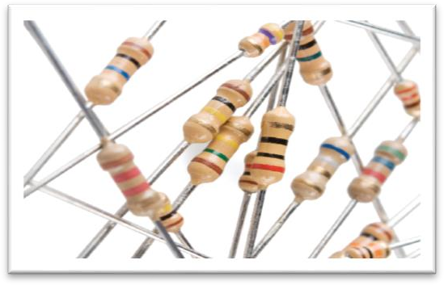

CALCULATION AND OBSERVATION:

|  |  |  |  |  |  |  |
| --- | --- | --- | --- | --- | --- | --- |
| S no | 1st band | 2nd band | Multiplier | Tolerance | Resistance  rang (Ω) | Verification DDM |
| 1 | Red(2) | red(2) | Orange(1000) | Gold(±5%) | 20995--  23205 | 20132 Ω |
| 2 | red(2) | Orange (3) | black(1) | Gold(±5%) | 21.85--  24.15 | 22Ω |
| 3 | Brown  (1) | black(0) | Red(100) | Silver(± 10%) | 9090--  11110 | 10kΩ |

**LAB RUBRICS: (Circuits & Systems-I Lab)**

|  |  |  |  |  |
| --- | --- | --- | --- | --- |
| **Criteria & Point**  **Assigned** | **Outstanding**  **4** | **Acceptable**  **3** | **Considerable**  **2** | **Below Expectations**  **1** |
| **Attendance and Attentiveness in Lab**  PLO10 | Attended in proper Time and  attentive in Lab | Attended in proper  Time but not attentive in Lab | Attended late but attentive in Lab | Attended late not attentive in Lab |
| **Equipment / Instruments Selection and Operation**  PLO1, PLO2, PLO3, PLO5, | Right selection and operation of appropriate equipment and instruments to perform experiment. | Right selection of appropriate equipment and instruments to perform experiment but with minor issues in operation | Needs guidance for right selection of appropriate equipment and instruments to perform experiment and to overcome  errors in operation | Cannot appropriately select and operate equipment and instruments to perform experiment. |
| **Result or Output/ Completion of target**  **in Lab**  PLO9, | 100% target has been completed and well formatted. | 75% target has been completed and well formatted. | 50% target has been completed but not well formatted. | None of the outputs are correct |
| **Overall, Knowledge** PLO10, | Demonstrates excellent knowledge of lab | Demonstrates good  knowledge of lab | Has partial idea about the Lab and  procedure  followed | Has poor idea about the Lab and procedure followed |
| **Attention to Lab Report**  PLO4, | Submission of Lab Report in Proper Time i.e. in next day of lab., with proper  documentation. | Submission of Lab Report in proper time but not with proper documentation. | Late Submission with proper documentation. | Late Submission Very poor  documentation |